

User Manual

Gym Management System

2025

SPRINT – SD 13 – SUMMER 2025

JUSTIN GREENSLADE, ASHTON DENNIS, JOSEPH GALLANT

Group: 1 | Version 1.0

### Table of Contents

Table of Contents 1

1. Introduction 3

2. System Requirements 3

3. Installation Guide/Getting Started 3

3.1 Logging system 4

4. Database Diagram 4

5. Project Structure 5

5.1 Main project 5

5.2 Libraries and scripts 5

6. Class Diagrams 6

6.1 User, Administrator, Member, Trainer, and Role 6

6.2 Membership and MembershipType 7

6.3 GymMerchandise and MerchandiseTypes 8

6.4 WorkoutClass and WorkoutClassType 9

7. Main Menu Overview 10

7.1 Register 10

7.2 Login 11

7.3 Quit 11

8. Admin Menu: 11

8.1 View All Users: 12

8.2 Delete a User: 12

8.3 View Memberships & Revenue: 13

8.4 Merchandise Management: 14

Add new merchandise: 14

Edit merchandise: 15

Delete merchandise: 16

Print all merchandise report and total stock value: 16

Back to Admin Menu: 17

9. Trainer Menu 17

9.1 Manage my workout classes 17

Create a Workout Class: 18

Edit a Workout Class: 19

Delete a Workout Class: 19

View My Workout Classes: 19

Back to Trainer Menu: 20

9.2 Purchase a Membership: 20

9.3 View Gym Merchandise: 20

9.4 Logout: 21

10. Member Menu 21

10.1 Browse Workout Classes: 22

10.2 View My Memberships: 22

10.3 Purchase a Membership: 23

10.4 View Gym Merchandise: 24

11. Exiting the Program 24

12. Troubleshooting Tips 25

13. FAQs 25

14. Contact Us 26

# Introduction

This Gym Management System is a Java console application designed to help a gym efficiently manage users, memberships, workout classes, and merchandise. The program supports different user roles such as Administrator, Trainer, and Member, each with their own set of capabilities.

# System Requirements

To run this program, you need:

* Java JDK 11 or higher installed
* A computer running Windows, Mac, or Linux
* Access to a terminal or command prompt

# Installation Guide/Getting Started

* Get the Project Files – On the project’s GitHub page, click **Code → Download ZIP** (then extract it) or **Clone with Git** (copy the link and run git clone <link> in your terminal).
* Install PGAdmin – Before running the program, download and install PGAdmin from https://www.pgadmin.org/download/. During setup, make sure you create a **username** and **password**. You’ll need these for the database connection.
* Open the Project in an Editor – Use Visual Studio Code (or IntelliJ/Eclipse), go to **File → Open Folder**, and select the extracted folder called FINAL_SPRINT-S3_JAVA
* Within that folder, navigate to the folder src/main/java/ and within that a folder called dbmanager. Open the file DatabaseConnection.java.
* Update the Database Credentials – On **line 19**, replace the username with your PGAdmin username. On **line 20**, replace the password with your PGAdmin password. Keep the quotation marks around both. Save the file.
* Run the Database Setup – Click the Run/▶️ button in your editor. The program will automatically connect to the database. If the gym membership database doesn’t exist, it will create it. It will then create the tables (if they don’t exist) and insert preloaded data if it hasn’t already been added.
* Run the Main Program – Now that the database is connected, navigate back to the menus folder within  the folder src/main/java/ to get to the folder main program. Open **Main.java** and click the Run/▶️ button in your editor.
* Use the Program – The Main Menu will appear. Type the number for your choice and press Enter to use the program.

## Logging system

The Gym Management System comes equipped with built-in logging capabilities. Errors and crashes, and general information such as data creation, updates and deletes are tracked in an appropriate file. Each entry includes a timestamp and description of the message. The files are stored in the root folder of the application.

* Error logs are tracked in the **gym_management_error_log.txt** file.
* Information logs are tracked in the **gym_management_log.txt** file.

# Database Diagram

# Project Structure

## Main project

|  |  |  |  |  |  |  |  |  |  |  |  |  |  |
| --- | --- | --- | --- | --- | --- | --- | --- | --- | --- | --- | --- | --- | --- |
|  | |  | | --- | | *DatabaseConnection* in **DBManager** is responsible for handling connections to the database and creating the database and tables when it is executed. | | *GymMerchandise* and *GymMerchandiseType* from **GymMerchandise** are entities used to represent the gym merchandise that is available for purchase. | | *GymMerchDAO* in **GymMerchManagement** handles creating, reading, updating, and deleting GymMerchandise from the database. | | *LoggingManagement* in **Logging** handles the writing of errors and infos to log files. | | *Main* in **MainProgram** is the main class used to launch the Gym Management System. | | *Menu* in **MainProgram** contains all the menu functions for each role. It is called by the *Main*. | | *MembershipsDAO* and *MembershipTypesDAO* in **MembershipManagement** handle creating, reading, updating, and deleting Memberships and MembershipTypes from the database. | | *Membership* and *MembershipType* in **Memberships** are entities used to represent the memberships assigned to a user. | | *UserDAO* and *UserService* in **UserManagement** handle the Login and Registration functionalities, as well as creating, reading, updating, and deleting Users from the database. | | *Administrator*, *Trainer*, and *Member* are entities used to represent users, inherited from the **User** class. They are assigned a Role. | | *WorkoutClass* and *WorkoutClassType* in **WorkoutClasses** are entities used to represent the Workout Classes taught by a Trainer. | | *WorkoutClassesDAO* and *WorkoutClassTypesDAO* in **WorkoutClassManagement** handle creating, reading, updating, and deleting WorkoutClasses and WorkoutClassTypes from the database. | |
|  |  |

## Libraries and scripts

|  |  |
| --- | --- |
|  | -The **lib** folder contains all the required libraries for BCrypt, used for password encryption, and PostgresSQL, used to access a Postgres database.  -The **scripts** folder contains the necessary script to create the database and the insertion of starting data, such as roles and users. |

# Class Diagrams

## User, Administrator, Member, Trainer, and Role

|  |
| --- |
| **User** |
| |  |  | | --- | --- | | -userId:int  -username:String  -password:String  -firstName:String  -lastName:String  -streetAddress:String | -city:String  -province:String  -postalCode:String  -email:String  -phone:String  -role:Role | |
| |  |  |  | | --- | --- | --- | | +User(userId:int, username:String, password:String, firstName:String, lastName:String, streetAddress:String, city:String, province:String, postalCode:String, email:String, phone:String, role:Role)  +User(user:User) | +getUserId():int  +getUsername():String  +getPassword():String  +getFirstName():String  +getLastName():String  +getStreetAddress():String  +getCity():String  +getProvince():String  +getPostalCode():String  +getEmail():String  +getPhone():String  +getRole():Role  +getFullName():String | +setUserId(userId: int):void  +setUsername(username:String):void  +setPassword(password:String): void  +setFirstName(firstName:String):void  +setLastName(lastName:String):void  +setStreetAddress(streetAddress:String):void  +setCity(city: String):void  +setProvince(province: String):void  +setPostalCode(postalCode: String):void  +setEmail(email: String): void  +setPhone(phone: String):void  +setRole(role: Role):void | |

|  |  |  |  |  |  |  |  |  |
| --- | --- | --- | --- | --- | --- | --- | --- | --- |
| |  | | --- | | **Administrator** | | +Administrator(userId:int, username:String, password:String, firstName:String, lastName:String, streetAddress:String, city:String, province:String, postalCode:String, email:String, phone:String, role:Role)  +Administrator(user:User) | | |  | | --- | | **Member** | | +Member(userId:int, username:String, password:String, firstName:String, lastName:String, streetAddress:String, city:String, province:String, postalCode:String, email:String, phone:String, role:Role)  +Member(user:User) | | |  | | --- | | **Trainer** | | +Trainer(userId:int, username:String, password:String, firstName:String, lastName:String, streetAddress:String, city:String, province:String, postalCode:String, email:String, phone:String, role:Role)  +Trainer(user:User) | |

|  |  |  |  |  |
| --- | --- | --- | --- | --- |
| |  | | --- | | **Role** | | -id:int  -name:String | | +Role(id:int, name:string)  +getId():int  +setId(id:int)  +getName():String  +setName(name:String) | | Three types of users can be created from the User class: Administrator, Member, and Trainer. They are assigned a Role, which defines their permissions. |

## Membership and MembershipType

|  |
| --- |
| **Membership** |
| -membershipId:int  -membershipType:MembershipType  -member:User  -startDate:Date  -endDate:Date |
| +Membership(membershipId:int, membershipType:MembershipType, member:User, startDate:Date, endDate:Date)  +getMembershipId():int  +setMembershipId(membershipId:int):void  +getMembershipType():MembershipType  +setMembershipType(membershipType:MembershipType):void  +getMember():User  +setMember(member:User):void  +getStartDate():Date  +setStartDate(startDate:Date):void  +getEndDate():Date  +setEndDate(endDate:Date):void |

|  |
| --- |
| **MembershipType** |
| -id:int  -name:String  -description:String  -cost:double |
| +MembershipType(id:int, name:String, description:String, cost:double)  +getId(): int  +getName():String  +getDescription():String  +getCost():double  +setId(id:int):void  +setName(name:String):void  +setDescription(description:String):void  +setCost(cost:double):void |

Members and trainers can purchase a gym Membership. A Membership is assigned a User, and a a MembershipType which includes the cost, name and description.

## GymMerchandise and MerchandiseTypes

|  |
| --- |
| **GymMerchandise** |
| -id:int  -merchandiseName:String  -merchandisePrice:double  -quantityInStock:int  -merchandiseType:MerchandiseType |
| +GymMerchandise(id:int, merchandiseName:String, merchandisePrice:double, quantityInStock:int, merchandiseType:MerchandiseType)  +getId():int  +setId(id: int):void  +getMerchandiseName():String  +setMerchandiseName(name: String):void  +getMerchandisePrice():double  +setMerchandisePrice(merchandisePrice: double):void  +getQuantityInStock():int  +setQuantityInStock(quantityInStock: int):void  +getMerchandiseType():MerchandiseType  +setMerchandiseType(merchandiseType: MerchandiseType):void |

|  |
| --- |
| **MerchandiseType** |
| -id:int  -merchandiseTypeName:String |
| +MerchandiseType(id:int, typeName:String)  +getId():int  +setId(id:int):void  +getMerchandiseTypeName():String  +setMerchandiseTypeName(typeName:String):void |

The GymMerchandise class keeps track of the products available for purchase by the members and trainers. Each GymMerchandise requires a MerchandiseType to be assigned.

## WorkoutClass and WorkoutClassType

|  |
| --- |
| **WorkoutClass** |
| -id:int  -workoutClassType:WorkoutClassType  -description:String  -trainer:Trainer  -dateTime:DateTime |
| +WorkoutClass(id:int, workoutClassType:WorkoutClassType, description:String, trainer:Trainer, dateTime:DateTime)  +getId():int  +setId(id: int):void  +getWorkoutClassType():WorkoutClassType  +setWorkoutClassType(workoutClassType:WorkoutClassType):void  +getDescription():String  +setDescription(description:String):void  +getTrainer():Trainer  +setTrainer(trainer:Trainer):void  +getDateTime():DateTime  +setDateTime(dateTime:DateTime):void |

|  |
| --- |
| **WorkoutClassType** |
| -id:int  -name:String  -description:String |
| +WorkoutClassType(id:int, name:String, description:String)  +getId():int  +setId(id: int):void  +getName():String  +setName(name: String):void  +getDescription():String  +setDescription(description: String):void |

The WorkoutClass class is responsible for the Workout Classes offered by a trainer. A trainer is a type of user. A WorkoutClass must be assigned a WorkoutClassType.

# Main Menu Overview

When you start the Gym Management System, you are greeted with the **Main Menu**. This menu lets you either register as a new user, log in if you already have an account, or quit the program.

The menu options are:

## Register

Selecting **Register** (option 1) allows you to create a new account in the system. You will be prompted to enter your personal details:

* **Username:** Choose a unique username for your account.
* **Password:** Enter a secure password.
* **First Name and Last Name:** Your full name as it will appear in the system.
* **Address, City, Province, Postal Code:** Your mailing information.
* **Email:** A valid email address for notifications.
* **Phone Number:** Your contact number.
* **Role:** Choose your role in the gym — Admin, Trainer, or Member.

After completing these steps, your account will be registered, and you can then log in with your credentials.

## Login

Selecting **Login** (option 2) lets you access your existing account. You will need to enter:

* **Username:** Your registered username.
* **Password:** Your account password.

If your credentials are correct, you will be logged in and redirected to the menu corresponding to your role:

* **Administrator Menu** if you are an admin.
* **Trainer Menu** if you are a trainer.
* **Member Menu** if you are a gym member.

If the login fails, you will be prompted to enter your credentials again.

## Quit

Selecting **Quit** (option 3) will exit the Gym Management System. A thank-you message will be displayed before the program closes.

# Admin Menu:

Once you log in as an **Administrator**, you will be presented with the **Admin Menu**, which allows you to manage users, view memberships and revenue, and handle gym merchandise.

The menu options are:

## View All Users:

Select option **1** to see a complete list of all users registered in the system, along with their contact information and roles.

* The list includes User ID, Username, Full Name, Email, Phone, Address, and Role.
* This helps you quickly access details of all users, including admins, trainers, and members.

After viewing the list, you can press Enter to return to the Admin Menu.

## Delete a User:

Select option **2** to delete a user from the system.



* You will be prompted to enter the **User ID** of the user you want to remove.
* When a user is deleted, all related memberships are also removed automatically to maintain data integrity.
* If you enter an invalid User ID or a non-numeric value, an error message will prompt you to try again.

After deletion, press Enter to return to the Admin Menu.

## View Memberships & Revenue:

Select option **3** to view a detailed report of all gym memberships, including member names, membership types, start and end dates, monthly costs, and the number of active months within the current year. 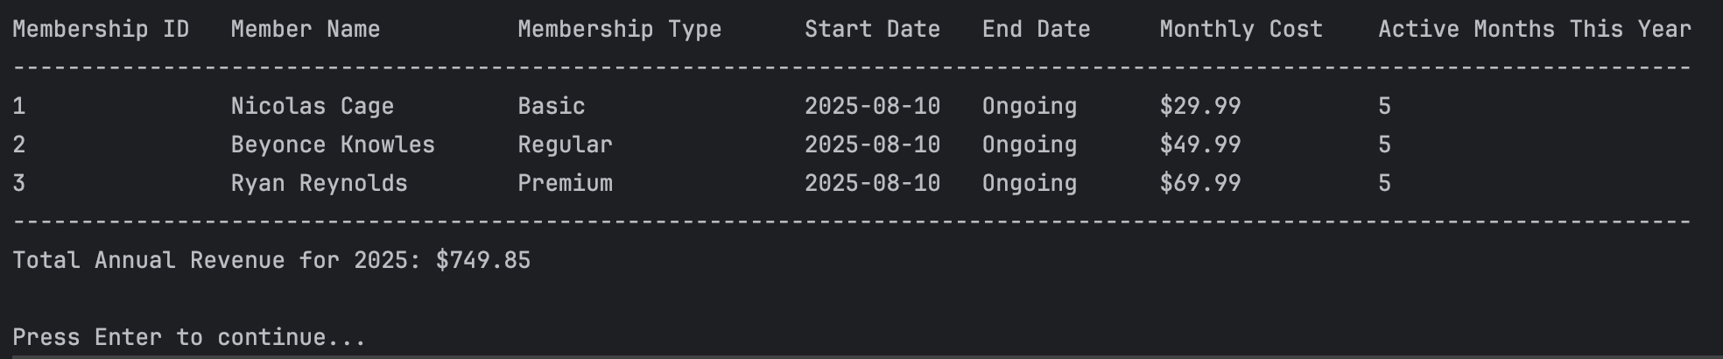

* The system calculates the **total annual revenue** generated from all active memberships for the current year.
* Ongoing memberships without an end date are counted through December 31st of the current year.
* This report helps administrators monitor membership distribution and financial performance.

After reviewing the report, press Enter to return to the Admin Menu.

## Merchandise Management:

Select option **4** to open the **Merchandise Management Menu**, where you can manage gym merchandise inventory.

The merchandise menu provides the following options:

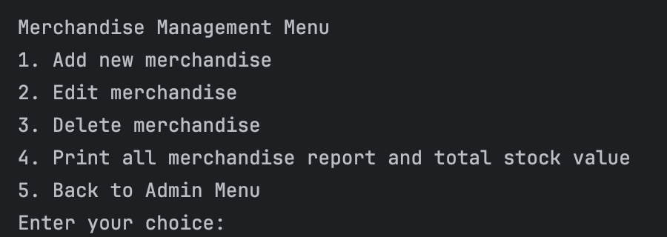

### Add new merchandise:

Select **option 1** to add a new item to the gym’s merchandise inventory.

You will be prompted to enter:

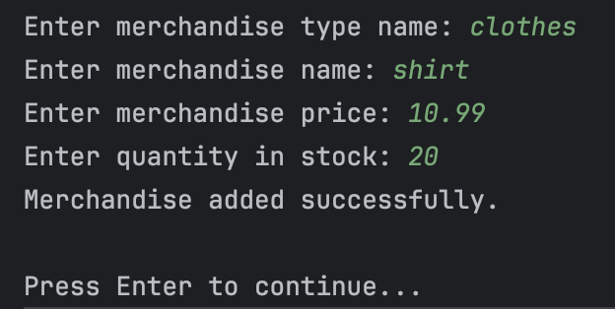

* **Merchandise Type Name:**

If the type already exists (e.g., "T-Shirt", "Water Bottle"), it will be reused.

If it does not exist, the system will automatically create it.

* **Merchandise Name:**

This must be unique within the same merchandise type.

If the same name already exists under that type, the system will stop you and return to the menu.

* **Merchandise Price:**

Enter a valid decimal number (e.g., 19.99).

* **Quantity in Stock:**

Enter a whole number (e.g., 50).

Once all fields are entered, the system saves the new merchandise and confirms:  
 Merchandise added successfully.

Press **Enter** to return to the Merchandise Management Menu.

### Edit merchandise:

Select **option 2** to modify an existing merchandise item.

You will be prompted to:

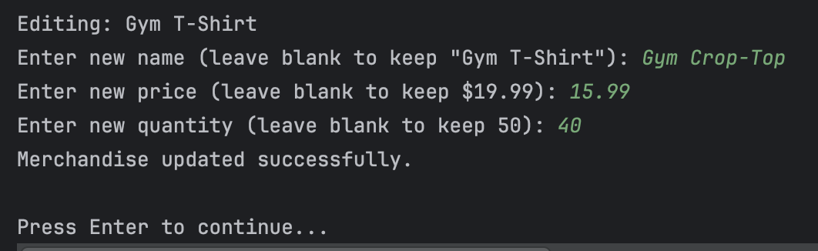

* **Enter the ID** of the merchandise you want to edit.

If the ID does not match any merchandise, you will see:  
 Merchandise not found.  
 and be returned to the menu.

* If found, the system will display the current merchandise details and allow you to:

**Enter a new name** (leave blank to keep the current one)

**Enter a new price** (leave blank to keep the current one)

**Enter a new quantity** (leave blank to keep the current one)

When all changes are entered, the system updates the record and confirms:  
 Merchandise updated successfully.

Press **Enter** to return to the Merchandise Management Menu.

### Delete merchandise:

Select **option 3** to remove merchandise from inventory.

You will be prompted to:

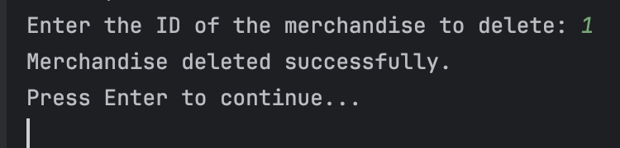

* **Enter the ID** of the merchandise you wish to delete.

If found, the merchandise will be permanently deleted, and the system will confirm:  
 Merchandise deleted successfully.

If no matching ID exists, you will see:  
 No merchandise found with that ID.

Press **Enter** to return to the Merchandise Management Menu.

### Print all merchandise report and total stock value:

Select **option 4** to view a formatted report of all merchandise in the system, along with the total stock value.

The report displays:

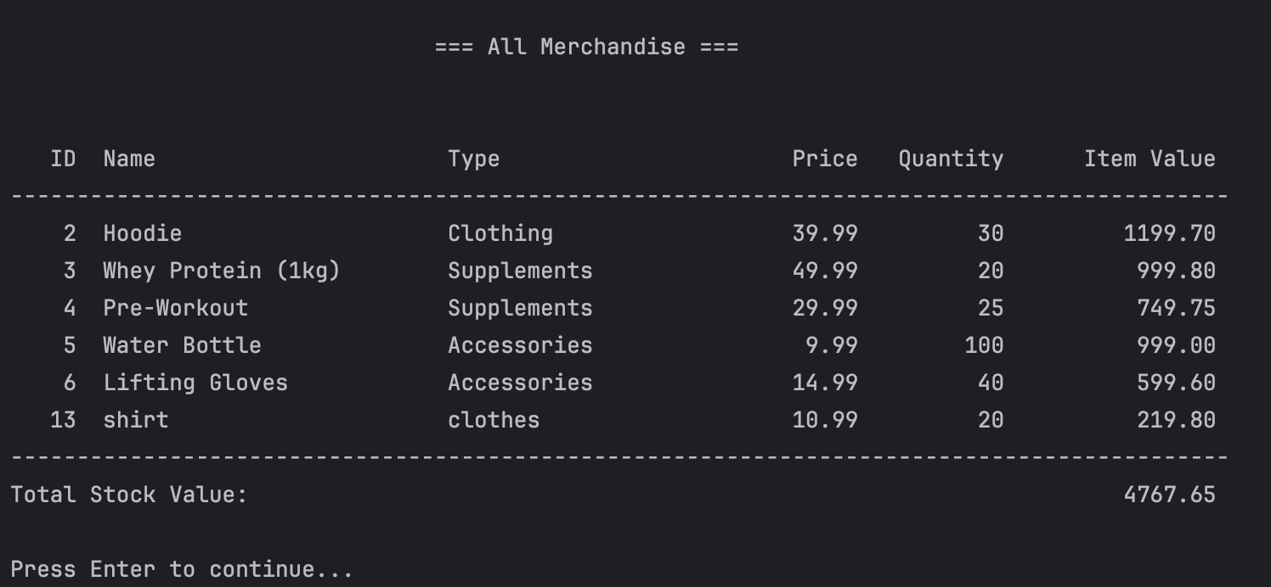

At the bottom, the **Total Stock Value** is calculated and displayed.

Press **Enter** to return to the Merchandise Management Menu.

### Back to Admin Menu:

- Select **option 5** to exit the Merchandise Management Menu and return to the main Admin Menu.

# Trainer Menu

Once you log in as a **Trainer**, you will be presented with the **Trainer Menu**, which allows you to manage a trainer's workout classes (create, update, delete or view), purchase a membership, show the gym merchandise or log out.

The menu options are:

## Manage my workout classes

**Option 1** will open a submenu to manage your workout classes:

### Create a Workout Class:

Select **option 1** to create a new workout class.

You will be prompted to:

* Enter the Workout Class Type ID, or type **l** to list all available class types.
* Enter a description for the new workout class.
* Enter the date of the class in **YYYY-MM-DD** format.
* Enter the time of the class in **HH:MM** format (24-hour clock).
* If all information is valid, the system will confirm:  
   *Workout class with ID: [ID] created successfully.*
* Press Enter to return to the Workout Class Management Menu.

Enter the **Workout Class Type ID** if you would like to use an existing one:

### Edit a Workout Class:

* Select **option 2** to edit a class you have previously created.
* You will be prompted to select the class ID, then update its details.

* Press Enter to return to the Workout Class Management Menu when finished.

### Delete a Workout Class:

* Select **option 3** to remove one of your classes from the schedule.
* You will be prompted to enter the ID of the class you wish to delete.

* Press Enter to return to the Workout Class Management Menu when finished.

### View My Workout Classes:

* Select **option 4** to view a list of all the classes you have scheduled.
* The display includes class IDs, names, descriptions, and scheduled times.

* Press Enter to return to the Workout Class Management Menu when finished.

### Back to Trainer Menu:

- Select **option 5** to exit the Workout Class Management Menu and return to the main Trainer Menu

## Purchase a Membership:

Select **option** **2** to purchase a new gym membership.

You will be prompted to:

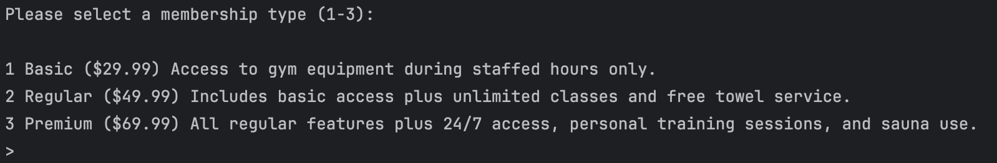

* Enter the Membership Type ID you would like to purchase.

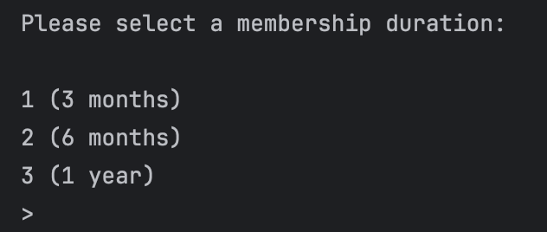

* Enter the duration you want for your membership (3 months, 6 months, or 1 year).

If the membership is created successfully, the system will confirm

Press Enter to return to the previous menu when finished.

## View Gym Merchandise:

* Select **option** **3** to show all the gym merchandise.
* This will display a table showing all merchandise currently in the system, including the merchandise ID, name, type, and price.

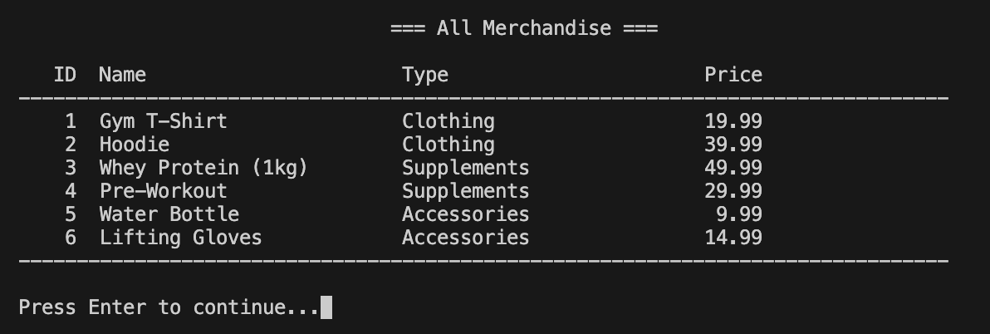

Press Enter to return to the previous menu when finished.

## Logout:

Select **option 4** to log out of the trainer account and return to the main login screen.

# Member Menu

Once you log in as a Member, you will be presented with the Member Menu, which allows you to browse available workout classes, view your total membership expenses, purchase a membership, show the gym merchandise, or log out.

The menu options are:

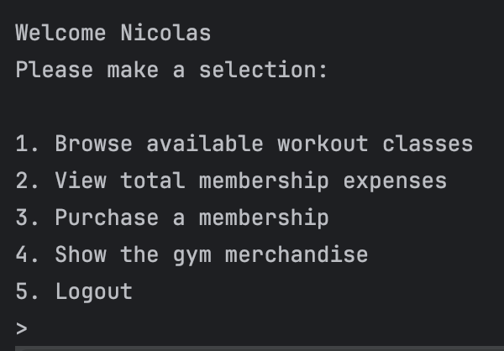

## Browse Workout Classes:

Select option 1 to view a list of all workout classes currently available at the gym.

The list displays:

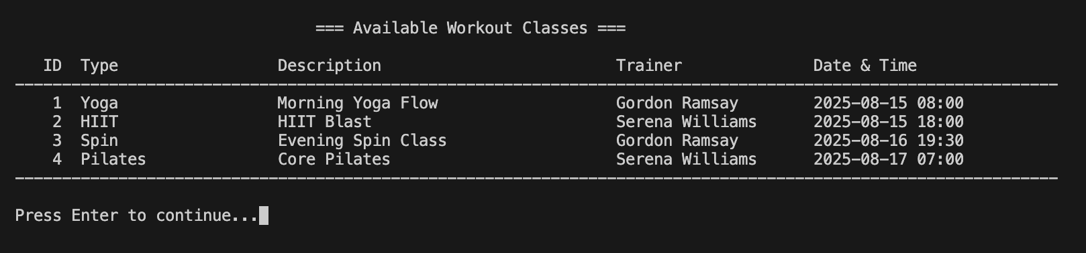

* Workout Class ID
* Workout Class Type
* Description
* Trainer
* Date and time of the class

If no workout classes are available, a message will be displayed.

Press Enter to return to the menu.

## View My Memberships:

Select **option** 2to view total membership expenses.

When you choose this option, the system will display a table containing:

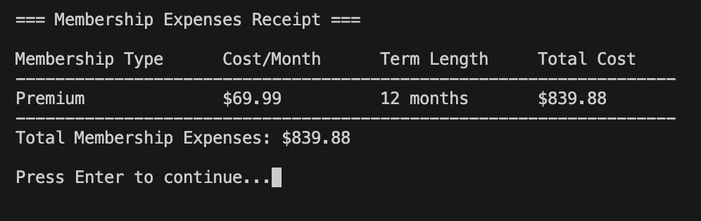

* **Membership Type** – The name of the membership plan you purchased.
* **Cost/Month** – The price you pay each month for that membership.
* **Term Length** – The total number of months in the membership term.
* **Total Cost** – The cost per month multiplied by the number of months.

After viewing your membership expenses, press **Enter** to return to the menu.

## Purchase a Membership:

Select **option** 3to purchase a new gym membership.

You will be prompted to:



* Enter the Membership Type ID you would like to purchase.



* Enter the duration you want for your membership (3 months, 6 months, or 1 year).

If the membership is created successfully, the system will confirm

Press Enter to return to the previous menu when finished.

## View Gym Merchandise:

* Select **option** **4** to show all the gym merchandise.
* This will display a table showing all merchandise currently in the system, including the merchandise ID, name, type, and price



Press Enter to return to the previous menu when finished.

# Exiting the Program

* After you log out from your personal menu (Admin, Trainer, or Member), you will return to the **Main Menu**. Here you have three options:

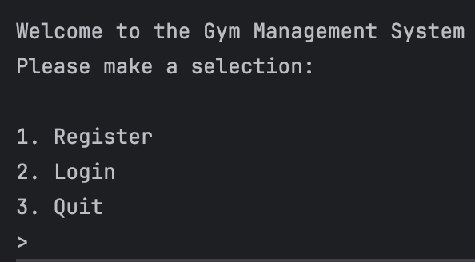

* To exit the program, select option **3** from the Main Menu. The system will then display a goodbye message and close.

.

# Troubleshooting Tips

If you encounter any issues while using the Gym Management System, please try the following steps:

* **The program does not start or run:**
  + Verify that Java JDK 11 or higher is installed and properly configured on your system.
  + Confirm that you have opened the correct project folder in your IDE (such as Visual Studio Code or IntelliJ).
  + Use the Run or Play button in your editor to launch the application.
* **Unable to log in or register:**
  + Ensure that your username and password are entered correctly (case-sensitive).
  + Complete all required fields during registration, including username, password, email, and role.
* **Menu options show “invalid option” or do not respond:**
  + Enter the number corresponding to your menu choice and press Enter.
  + Avoid entering letters or special characters unless specifically requested.
* **Changes are not saved or data does not display:**
  + Confirm that the PostgreSQL database is running and properly connected.
  + Verify your database configuration settings in the project.
  + Make sure the necessary database tables exist and have been set up correctly.
* **Workout classes, memberships, or merchandise are missing:**
  + These items must be added by an Admin or Trainer before they appear.
  + Restart the program if new data was recently added.
  + Some features and data visibility depend on your user role.
* **Application crashes or displays errors:**
  + Review any error messages for guidance on the issue.
  + Restart the application and try again.
  + Consult the application’s log file for detailed error information if problems persist.
* **General recommendations:**
  + Always log out properly before closing the program to ensure data integrity.
  + Restart the application if you encounter unexpected behavior.

# FAQs

**Q: What user roles are available in the system?**  
 A: There are three roles—Admin, Trainer, and Member. Each role has specific access and functions within the system.

**Q: How do I register a new user?**  
 A: From the main menu, select “Register.” You’ll need to provide a username, password, email, phone number, address, and select a role.

**Q: How do I purchase a membership?**  
 A: Log in as a Member or Trainer and select the option to purchase a membership from your menu.

**Q: Can I view workout classes if I’m not a Trainer?**  
 A: Yes. Both Members and Trainers can browse available workout classes, but only Trainers can create, update, or delete classes.

**Q: How do I manage merchandise?**  
 A: Admins can add, update, or remove merchandise items and view stock reports. Trainers and Members can only view available merchandise.

**Q: What database is used, and do I need to set it up?**  
 A: The system uses PostgreSQL. You’ll need to install and configure the database, then run the provided SQL scripts to create tables and seed initial data.

**Q: How do I exit the program safely?**  
 A: From the main menu, choose the “Quit” option. Logging out from any user menu will return you to the main menu where you can then exit.

**Q: What if I enter an invalid menu option?**  
 A: The system will prompt you to enter a valid number. Just type the correct option number and press Enter.

# Contact Us

If you have any questions or need further assistance, feel free to reach out:

• **Email:**

Justin: Justin.Greenslade@keyin.com Joseph: Joseph.Gallant@keyin.com Ashton: Ashton.Dennis@keyin.com